Allegations Against Staff Policy

Allegations against staff, supply staff, volunteers or other adults

Updated by Director of Inclusion/Safeguarding and approved by trustees: October 2022.
Reviewed at least annually.

1. Introduction and principles
There may be occasions when a pupil or adult makes an allegation against a member of staff, supply teacher, volunteer or other adult. There are two aspects to consider when an allegation is made:
- Looking after the welfare of the child and ensuring that the child is not at risk
- Investigating and supporting the person subject to the allegation.
When dealing with allegations, schools should:
- apply common sense and judgement;
- deal with allegations quickly, fairly and consistently; and
- provide effective protection for the child and support the person subject to the allegation.
All staff are expected to recognise the importance of confidentiality without compromising the need to refer safeguarding concerns.

NB: Keeping Children Safe in Education refers and sets out in specific detail the particular risks that may arise when employing supply teachers. Headteachers, DSLs and those involved in recruiting and managing supply teachers should make themselves familiar with this guidance.

2. Referring allegations to the Local Authority Designated Officer (LADO)
Each local authority appoints a LADO who is responsible for managing all child protection allegations made against staff and volunteers who work with children in their area.
The LADO must be consulted within 24 hours if there are concerns that a worker (member of staff, supply teacher or volunteer) has done any of the following inside or outside of school:
- Behaved in a way that has, or may have, harmed a child;
- Possibly committed a criminal offence in relation to a child; or
- Behaved towards a child in a way that indicates they may pose a risk of harm to children;
- Behaved or may have behaved in a way that did not involve children, but indicates they may not be suitable to work with children (this is known as a Transferable Risk).
How to make a LADO referral: Contact details for each school’s LADO, and a link to the LADO referral form, are on the front of the Q1E Child Protection and Safeguarding policy.
- Allegations about a staff member, volunteer or supply teacher should be referred to the Designated Safeguarding Lead (DSL) and Head. The DSL/Head will refer to the LADO.
- Allegations about a Head/Executive Head should be referred to the CEO and the Trust’s safeguarding lead, or direct to the LADO.
- Refer allegations about the CEO to the Chair of the Trust Board and the Trust’s safeguarding lead, or direct to the LADO.

The person referring the allegation to the LADO should discuss the nature, content and context of the allegation with the LADO, agree the course of action to be taken, and normally assign a case manager within the school. The case manager’s role is to:
- manage and minimise the stress caused by the allegation
- inform the individual as soon as possible, explaining the likely course of action, guided by the LADO, and the police where necessary
- advise the individual to contact their trade union representative, or a colleague, for support
- appoint a named representative to keep the person informed about the progress of the case
- provide access to counselling or medical advice where appropriate, and,
- not prevent social contact with work colleagues and friends, when staff are suspended, unless there is evidence to suggest this may prejudice the gathering of evidence.
3. Other referrals that may need to be made
- Immediate referrals to children’s social care: Where the school identifies that a child has been harmed, or there may be an immediate risk of harm to a child, they should contact children’s social care immediately. How to make a referral to social care: Details for children’s social care in your area can be found on the front of the Q1E Child Protection and Safeguarding Policy.
- Referrals to the police: If the situation is a safeguarding emergency, the school should contact the police immediately. If there is an allegation about someone who no longer works at the school, contact the police rather than the LADO. How to contact police: In an emergency, always call 999. In a non-emergency situation, call 101 or report online: www.police.uk/pu/contact-the-police/report-a-crime-incident/.
- Referrals to the Disclosure and Barring Service (DBS): Employers are legally required to make a referral to the DBS where they consider an individual has engaged in conduct that harmed (or is likely to harm) a child; or if a person otherwise poses a risk of harm to a child. If the allegation is substantiated. but the person has left (i.e. the person is dismissed, resigns, or the school/trust ceases to use the person’s services) then the school still has a legal duty to make a referral to the DBS, so that they can consider whether the person is required to be included on the barred lists. How to make a DBS referral: www.gov.uk/guidance/making-barring-referrals-to-the-dbs
- Referrals to the Teaching Regulation Agency (TRA): For teaching staff, the school must also consider whether to refer to the TRA, to consider prohibiting them from teaching. How to make a TRA referral: www.gov.uk/government/collections/teacher-misconduct#referrals
- Referrals to Ofsted: Concerns about Early Years staff must also be referred to Ofsted.

4. ‘Low level’ concerns
You should always report even ‘low-level’ concerns about a member of staff, supply staff, volunteer or contractor, so that any potential patterns of inappropriate behaviour can be identified. Low-level concerns could include, but are not limited to:
- being over friendly with children;
- having favourites;
- taking photographs of children on a personal mobile phone;
- engaging with a child on a one-to-one basis in a secluded area or behind a closed door;
- using inappropriate sexualised, intimidating or offensive language.
The Staff Code of Conduct sets out further details of what conduct is and is not acceptable.
How to report a low level concern: All low-level concerns should be reported to the DSL or the head. If they are reported to the DSL, the DSL should inform the head in a timely fashion according to the nature of the concern. The head is the ultimate decision maker on the course of action to be taken, although he/she may wish to consult with the DSL. Low-level concerns about supply staff and contractors will be notified to their employers. If there is any doubt as to whether something is a low-level concern or in fact meets the harm threshold, the school should consult with their LADO.

5. Unsubstantiated allegations
If an allegation is determined to be unsubstantiated, unfounded, false or malicious, the LADO and the case manager should consider whether the child and/or the person who has made the allegation is in need of help or may have been abused by someone else and this is a cry for help. In such circumstances, a referral to children’s social care may be appropriate.
If a report is shown to be deliberately invented or malicious, the school should consider whether any disciplinary action is appropriate against the individual who made it, consulting HR for advice.

6. Whistleblowing

Concerns about the school/trust can be raised through the process set out in the Q1E Whistleblowing Policy. Whistleblowing is the act of telling the authorities or the public that the organisation you work for is doing something immoral or illegal, and which is in the public interest.

Appendix A: Managing allegations against staff: Flow Chart
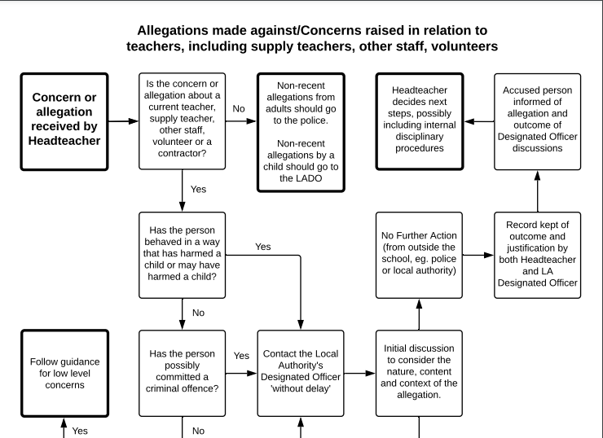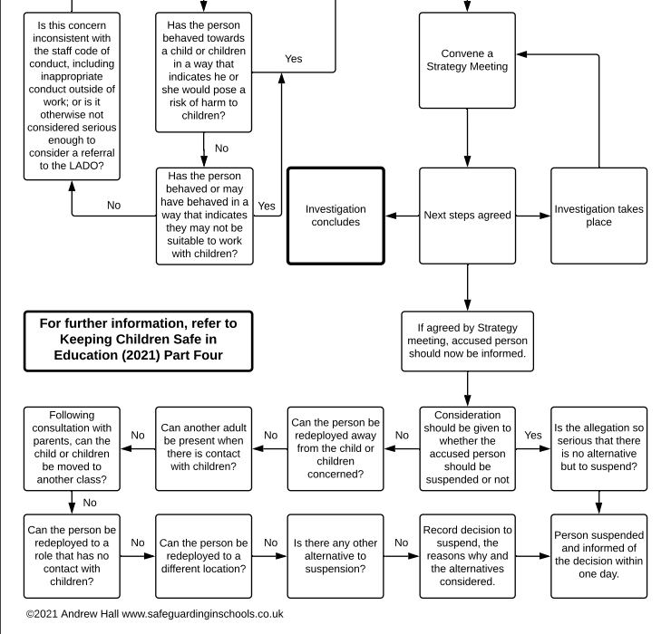
Appendix B: Managing low level concerns: Flow Chart

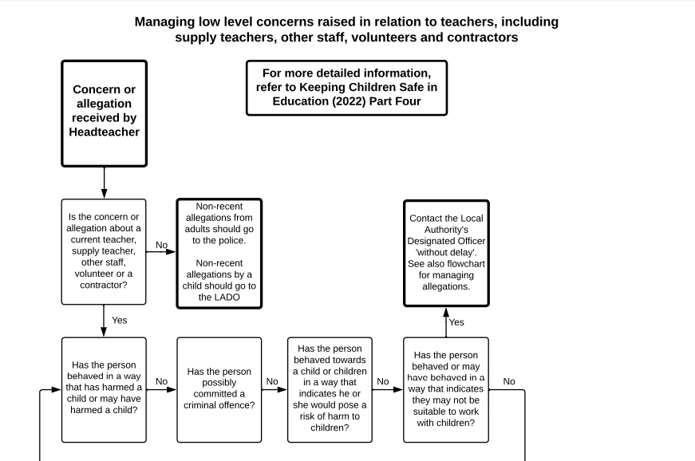
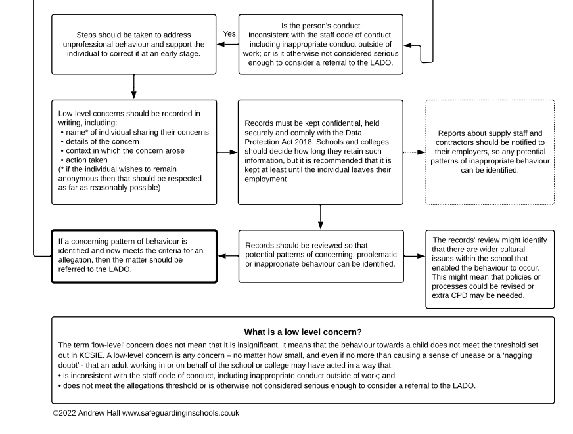

Appendix C: LADO referral form: Wandsworth

AGENCY REPORTING FORM FOR ALLEGATIONS AGAINST STAFF AND VOLUNTEERS WORKING WITH CHILDREN WITHIN THE LONDON BOROUGH OF WANDSWORTH

WHEN TO USE THIS FORM

This form must be filled in and sent to the Wandsworth MASH in every case where it is alleged or there are concerns that a person working with children has:-

- Behaved in a way that has harmed a child or may have harmed a child
- Possibly committed a criminal offence against or related to a child
- Behaved towards a child or children in a way that indicates they may pose a risk of harm to children
- Behaved or may have behaved in a way that indicates they may not be suitable to work with children

Every incident should be recorded on this form and reported to the Wandsworth MASH.

If you are unsure as to whether the incident or concern needs to be referred, please ring the LADO to discuss. The LADO can be contacted on LADO@richmondandwandsworth.gov.uk or LADO@wandsworth.gov.uk – or 0208 8717440

If the matter is serious or there are immediate concerns for the child’s safety or wellbeing, the referral must be made to Wandsworth MASH. MASH@wandsworth.gov.uk – 0208 8716622

If you do not have any relevant information for specific sections, please make this clear.

All allegations must be reported to the Wandsworth MASH within 24 hours.

You will be asked to provide associated relevant documentation once the information has been evaluated by the LADO. You will be advised regarding the appropriate action to be taken.

AGENCY Details

Date of referral
Referrers name
Referrers job title
Place of work & address
Tel number
Email
Best contact times
Who is your Designated Manager/Child Protection Lead
If a school, please give contact details of Head and Chair of Governors
Status of organisation e.g. LA, private, voluntary, etc
Who is your HR lead for allegations against staff

Allegation Details

Date of alleged incident
Date allegation reported to referrer
Category of Abuse Alleged – please tick | Physical Emotional Sexual Neglect
Does this referral concern mishandling of medication – if so, please give details of medication concerned and purpose of the medication
Who has made the allegation e.g. child, parent, other professional etc
How was the allegation e.g. in person, by phone, letter and to whom
Who else has been informed regarding allegation
Full details of allegation
Where is it alleged the incident took place
What action if any has been taken regarding the allegation
Is there an allegation of an injury and if so please describe
Has a member of staff seen the injury, if so, they may be asked to complete a body map diagram
If injury has parent been advised to take child to GP and if so, have they done so?
Are written incident reports available and if so by whom; please supply
Are there witnesses to the alleged incident; please give details
If there has been a delay in reporting the allegation state why
Are the parents/carers of the child aware of the allegation and if so state when /their views
Is the child aware of the referral and if so when, and what their views are
Did an allegation of physical abuse follow an authorised / unauthorised restraint? | Yes No
If the allegation relates to restraint has staff member had Team Teach or similar training and when

Details of person/s subject to the allegation please repeat box if more than one person

Person subject to allegation known /unknown
First name
Surname
Title
Job title
DOB
Home address
Ethnicity
Length of employment
Date of last DBS
Details of references taken up
What is the status of the employment e.g. f/t, p/t, agency, volunteer etc
If agency etc please give contact details
Have they been subject to previous allegations and if so, please provide full details
Are there any other concerns/issues of relevance regarding this person
Does this person work in any other capacity with children either paid/unpaid?
Does this person have children of their own? If so, please provide name(s), DOB(s) and address details
Has the person been suspended/advice taken from HR

Details of potential victim/child please repeat box if more than one child

Alleged victim known or unknown/no victim
First name
Surname
DOB
Gender
Ethnicity/Religion
Home address/tel.
Parent’s/carers names/contact details
Who has PR for the child
First language of child and parents/carers – is an interpreter required
Issues of disability/communication/literacy for child or parent/carer
Any other family members/significant persons for this child
Has the child made a previous allegation and if so, please give details
Is/has this child been Looked After or subject to a Child Protection Plan, Child in Need Plan
GP / Health Visitor / School Nurse details
Are there any known concerns about this child / young person
Other information of relevance re this child and the allegation

Please give details of any other information of relevance

Referrer’s name:

Referrer’s signature:
(please add electronically)

Date:

Appendix D: LADO referral form: Bromley
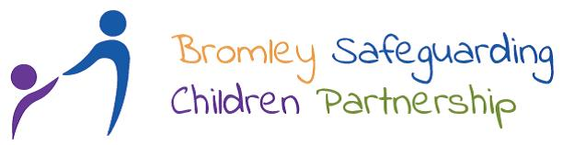

Allegations against staff or volunteers who work with children
Referral form to the Local Authority Designated Officer (LADO)

A referral needs to be made within 24 hours of it becoming known that an allegation has been made that a person who works with children has:
- Behaved in a way that has harmed, or may have harmed a child
- Possibly committed a criminal offence against, or related to a child
- Behaved towards a child or children in a way that indicates they may pose a risk of harm to children

This referral form must be completed and emailed to:
LADO@bromley.gov.uk

If you are unsure about whether a referral should be made or have a concern about a member of staff or volunteer in relation to their behaviour at work or in their private life, the LADO can be contacted for consultation/advice.

Email: LADO@bromley.gov.uk Telephone: 020 8461 7775 Mobile 07850 921 631

For child protection enquiries that are not related to an allegation against staff or volunteers who work with children, please call Bromley MASH on 020 8461 7373/7379/7026 or email mash@bromley.gov.uk, outside office hours 0300 303 8671. If you think a child is at immediate risk of significant harm phone the Police.

Details of the person against which the allegation, complaint or concern has been made:

Full name
Date of Birth & Gender
Ethnicity, Religion & Language
Home Address & Tel
Role/ Job title
Name of the setting where the person works
Is the person an employee/volunteer or agency worker
If an agency worker, what are the contact details for the agency?
Length of service in current post
When was the person last DBS checked? Was it clear?
Are there any previous allegations, complaints or concerns in relation to this person (not necessarily safeguarding related)? Give Details
Does this person have contact with children in any other capacity inc. as parent? Give details
Is the person aware that an allegation, complaint or concern has been raised? Their view?

Details of the child/ young person subject of the allegation, complaint or concern:
Full name
Date of Birth & Gender
Ethnicity, Religion & Language
Home Address
Parent/carers names and contact details
Names and dates of birth of any siblings.
Has the child/young person made any previous allegations?
Does the child/young person have a social worker? Give details
Does the child/young person have any Special Needs? If so, what?

Details about the allegation, complaint or concern:
Date and time of the alleged incident
Person/agency initially receiving the allegation, complaint, or concern and when?
Where did the incident take place?
Brief description of the incident?
Does the child/ young person have an injury or experienced harm?
Was the alleged incident witnessed? If so, give name, role and contact details of the witnesses.
Have the parents/carers of the child been informed? Their view?
What safeguarding measures are currently in place?
If a crime has been committed has it been reported to the police? If so, when and what is the CRS #?

Details of the person completing this form:
Name
Agency
Role/Job Title
Contact Number
Email Address
Date of Referral to LADO

Please list the contact details & role of those who would need to be invited to an ASV (Allegations against Staff and Volunteers Meeting:

Actions Taken by Employer/LADO Advice

Outcome of Internal Management Investigation/Decision of LADO & Rationale

